Welcome Club
January 29 2021~ 3:30pm-4:30pm

Character lesson of the month:

Fairness/Equity -
Asking for Help and Giving Help

- Everyone gets what they need to be successful

3:30-3:35

Introduction to Welcome Club - (Coach Colin)
-Build friendships
-Help each other
-Discuss problems and issues with coaches and students
-Have fun!
*Review Welcome club’s foundation for how we treat each other: Treat others the way you want to be treated.

-Transition- (Coach DeVon) “Ok let’s have the coaches introduce themselves and say their favorite thing to do on rainy days!”

3:35-3:45

Introduction of Coaches- We will take turns sharing our name and favorite thing to do on rainy days.

-Transition- (Coach Amy) “Now I want to introduce our lesson for today.”

Introduction of Character Lesson- “Today we are continuing to talk about equity and fairness. We are going to focus on asking for help and giving help.
-Transition- (Coach Becca) “Let’s get into our breakout rooms and we can start with a game! Everyone make sure you have your Welcome Club bag, scissors, and pen.”

3:45-3:55

- Coaches, start your group time by having each student introduce himself or herself. Next, you will need to explain the rules of the game. Assistant coaches are encouraged to participate.

ICEBREAKERS - Catch Phrase
Directions: Students will all think of an activity they want to learn or grow in (ex- soccer, math, musical instrument, English, painting, video games, cooking). Each student and coach will take turn share what they want to learn but they cannot say the exact words of the activity (ex- I want to learn how to put color on a brush and add the color to a paper. As I add more color a scene will start to develop on my paper. What do I want to learn? Painting!)
Kids should not start guessing what activity is being described until the person is done. That way there should be few interruption. No repeats of activities.
Challenge the kids to think of a variety of activities so utilize the chat if needed. This game will help students practice their English skills and encourage a growth mindset of learning and seeking help from a teacher, tutor, parent or coach.

-Transition- (coaches) “I loved hearing about all the things you guys want to learn and grow in. Asking for help and being a helper is so important in equity”.

3:55-4:10

Lesson: Fairness and Equity- Asking for Help and giving Help

Coaches:
“Let’s review the definition of fairness/equity. Everyone get’s what they need to be successful. And successful means doing and completing a goal. You all just shared about some goals you have. To do those activities well you will need to ask someone for help. We all have things to learn and asking for help is a great way to start learning! (Give a specific example from the game).
It’s important to know what you want to grow in and what you are good at. We talked last Welcome Club about listening to each other so we will know how to help someone who isn’t being treated in an equitable way. You all can be and are great helpers! Can someone tell me how you all are helpers in school or in your home? (Call on a specific student if your group is quiet. If students are not talkative ask more specific questions about helping in school. Ex- who has helped translate for a new student at school? Who has shown a new students around school last year? How else have you helped your teacher or another student in school? Who has helped their mom or dad in the store? Who has helped a younger/smaller brother or sister put on their shoes or coat? Who has played in the park with a kid who just arrived in USA and welcomed them to Sacramento?)
You all have so many talents and strengths that your family and your school need so everyone can succeed! You are an important part of the community. I’m so glad you’re here and I can learn from you! So we challenge you to keep your eyes and ears open for those around you who are not being treated in an equitable way and help and speak up so they can succeed.
Transition- “Today we are going to do a craft to help us remember that we are all helpers.”
4:10-4:30 Craft
Helping Hands sun catcher

The students will be making a sun catcher out of tissue paper and contact paper.
The students will first use a pen to trace their hand on the square of tissue/contact paper.

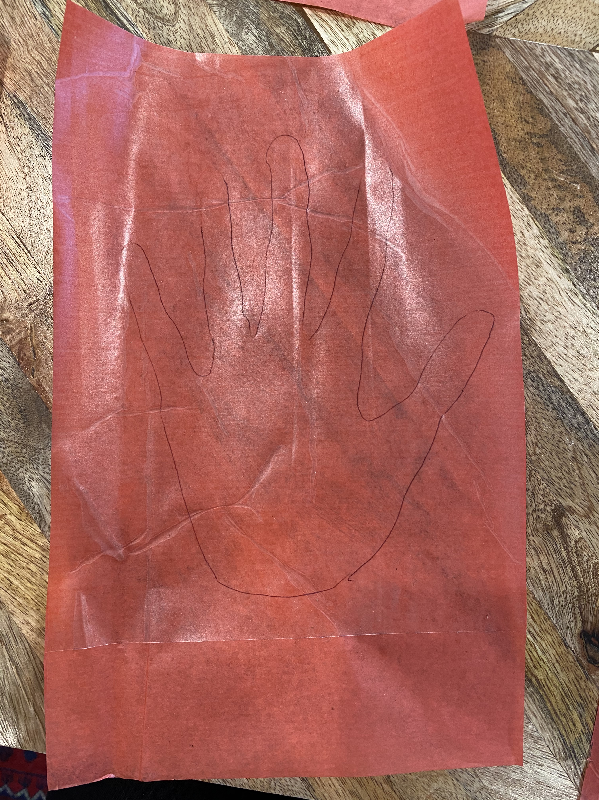

Next, the students will cut out the hand shape.

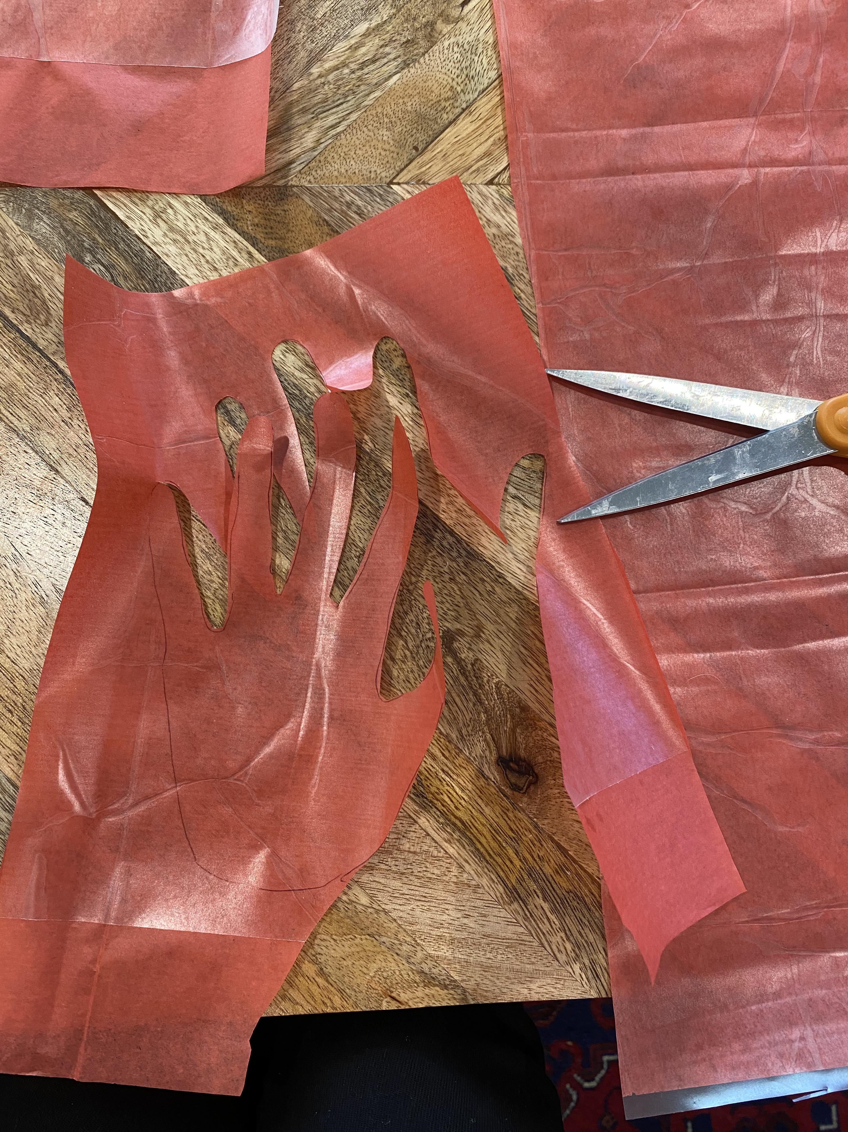

Last, the students can hang their hand sun catcher in their window.

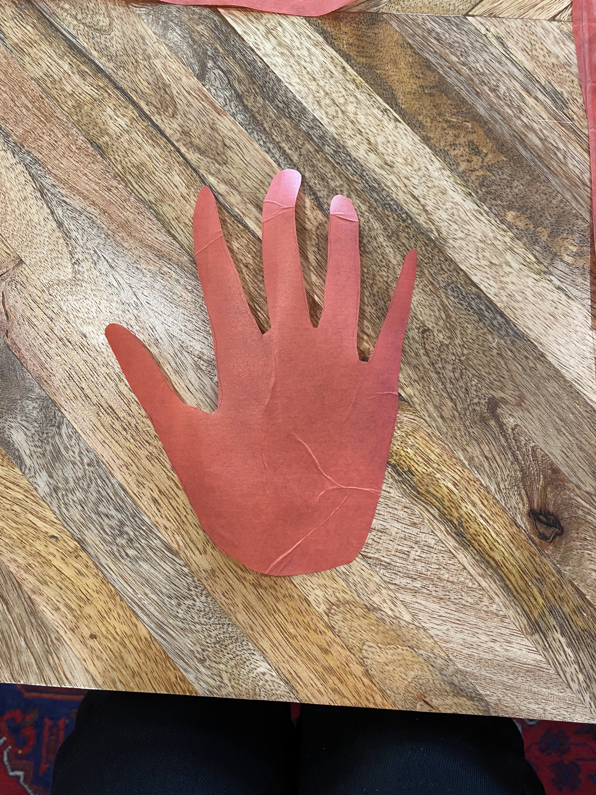

Bonus-If there is time and your students are interested, fold down the third and forth fingers to show the “I love you” sign.
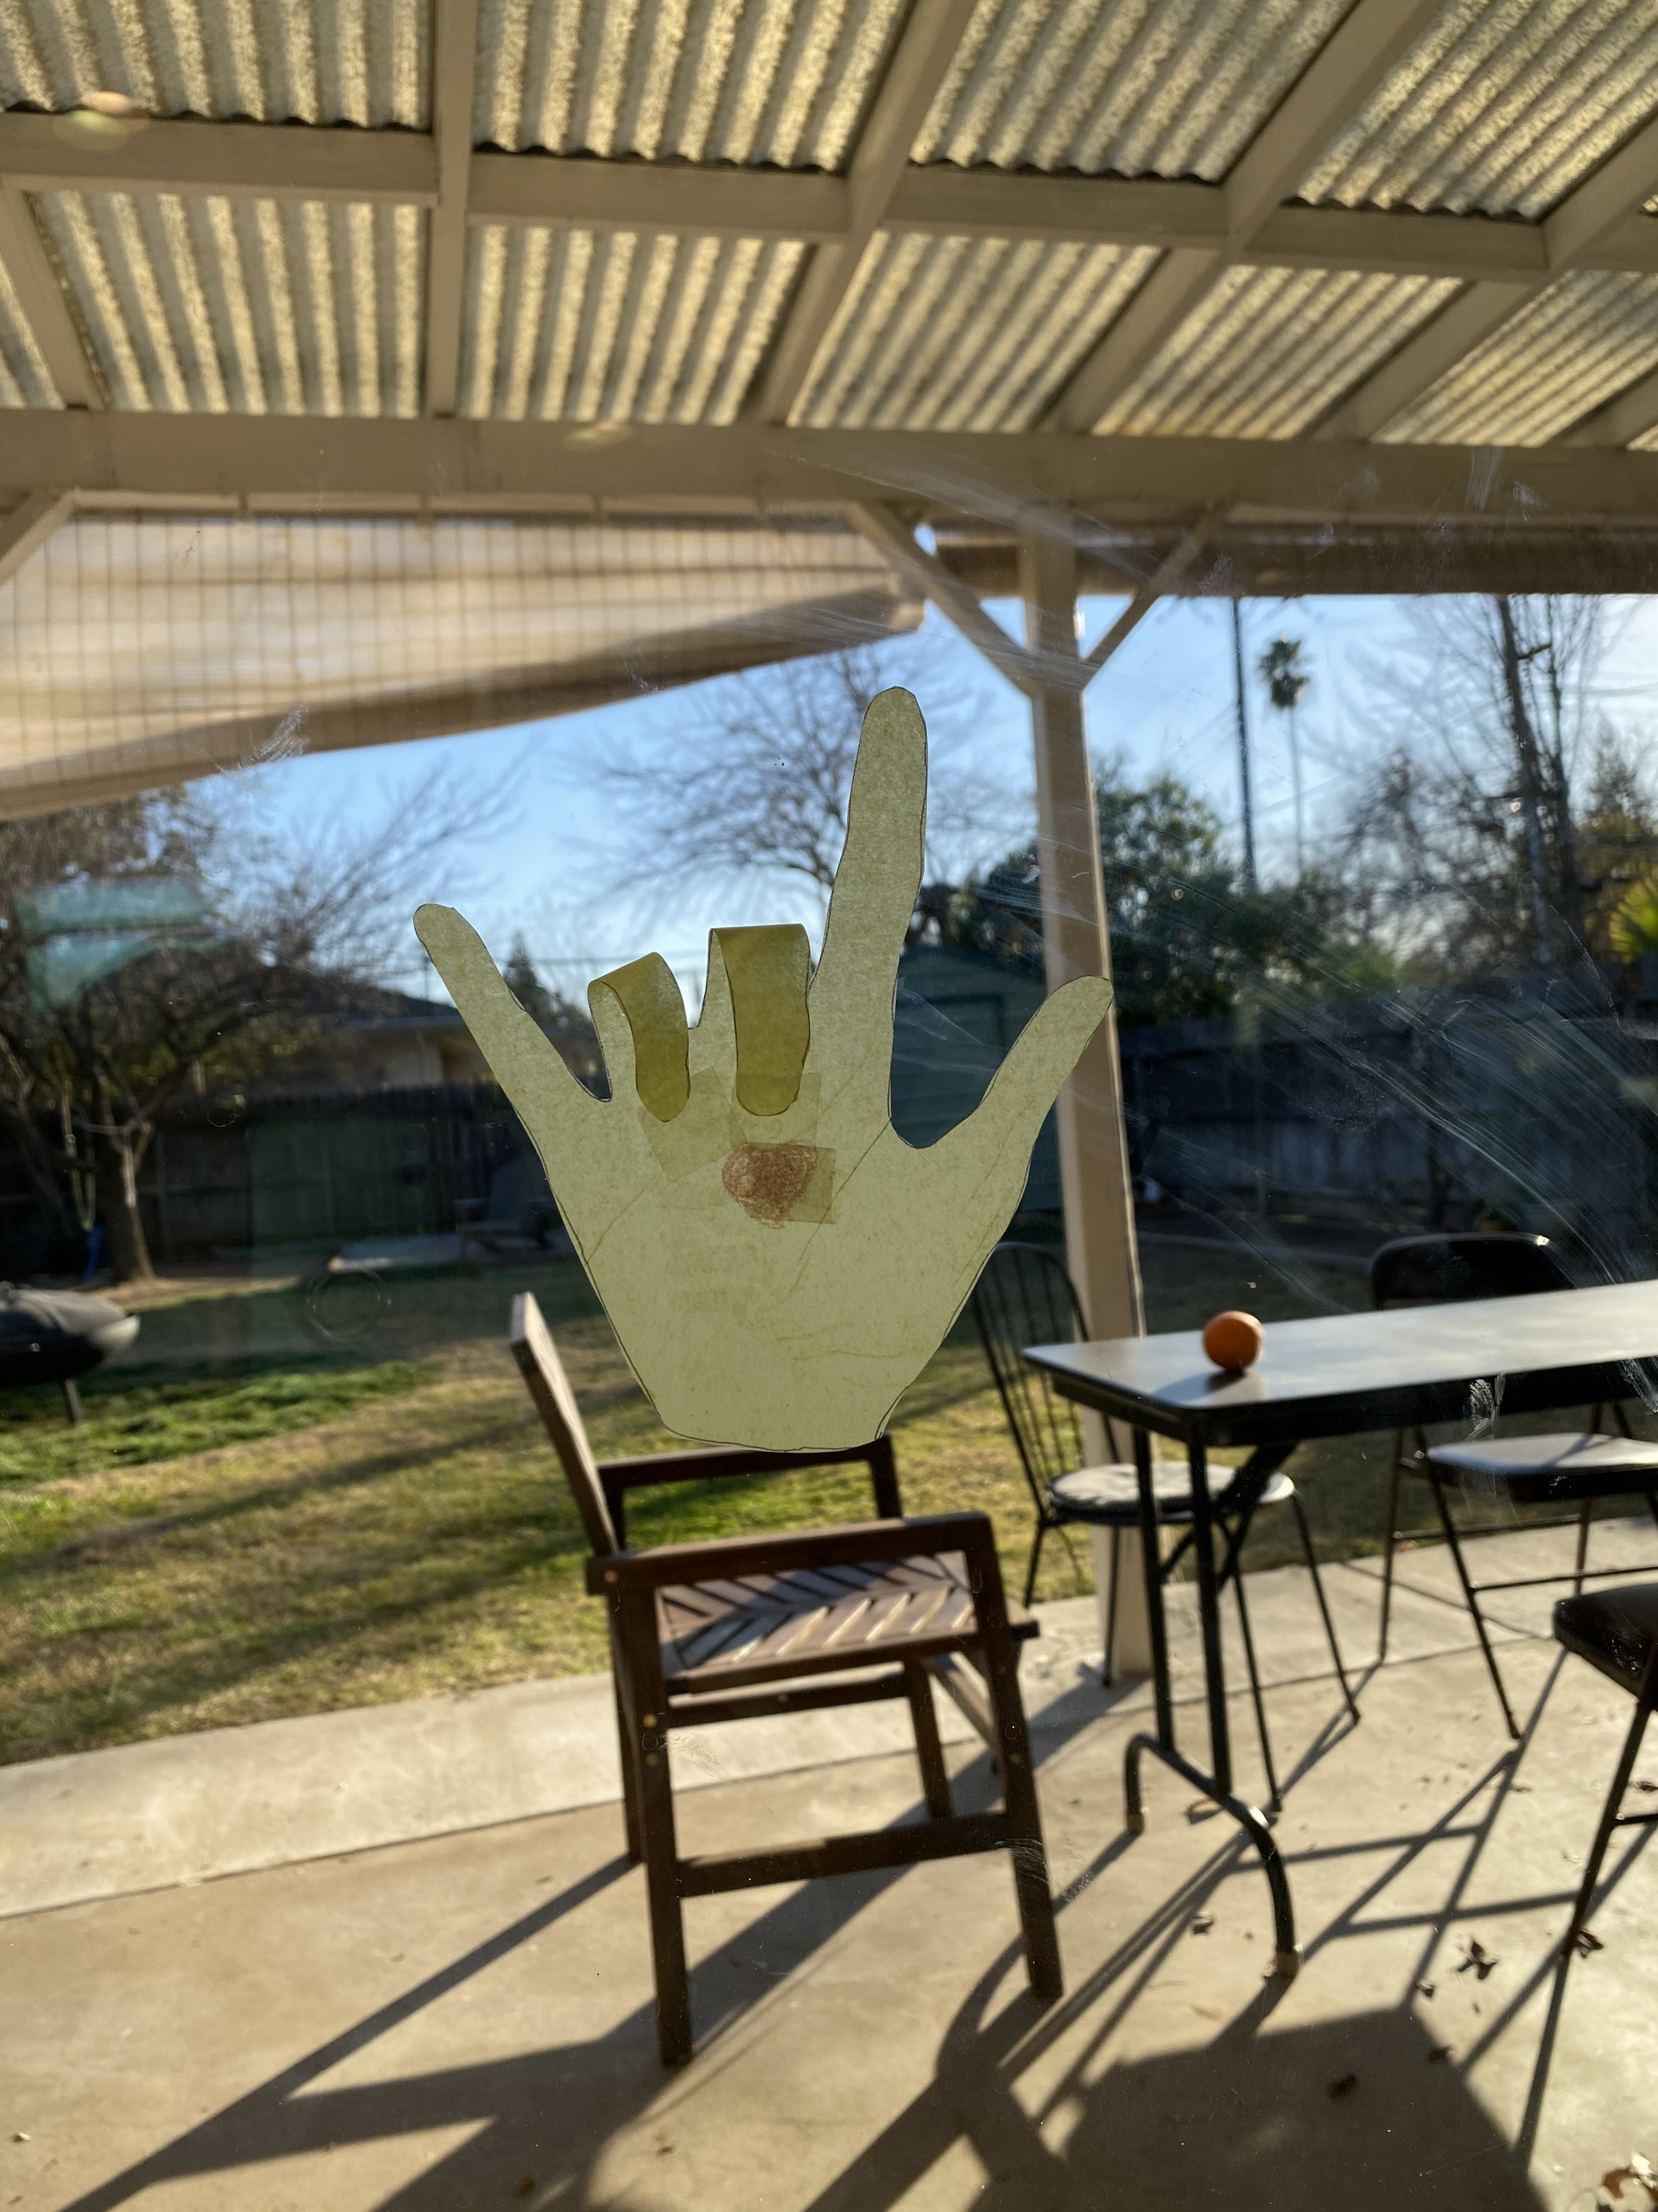

Conversation starters and fun question ideas-

1. If you could make up a brand new school subject, what would it be?
2. Can you remember a time when you laughed so hard you snorted?
3. Make up a new holiday.
4. What is you favorite letter of the alphabet? Why?
5. If someone gave you $50 dollars what would you do with it?
6. Would you rather eat your least favorite vegetable or have extra homework?
7. When you are sad how do you make yourself feel better?
8. Would you rather pack your lunch or buy from the cafeteria?
9. What is your favorite day of the week?
10.What is the best way to eat an Oreo?
11.What do you normally do during recess?
12. Which state shape do you like the best?
13. Do you have a favorite place in your town?
14. Would you rather scream or whisper?
15. Would you rather take a picture or be in the picture?
16. When you play tic-tac-toe, do you choose to be Xs or Os?
17. When you’re waiting for something, how do you pass the time?
18. What is your favorite chore?
19. If you could do one thing, everyday, for the rest of your life, what would it be?
20. Once you lie down in bed, how long does it take you to fall asleep?
21. If you had a robot for one day what would you ask it to do?
22. What is your favorite thing about yourself?
23. How do you make friends?
24. What’s your favorite thing to do on a snow day?
25. If you could design a zoo, which animal would you have the most of?

4:30

Wrap up and Goodbyes
- Updates and information- (Coach Makayla)
- Tutoring- Thursday 2:30pm Reading pod- Monday 3:30(Coach Megan/Makayla)

*Coaches stay on for quick debrief

My Own Two Hands- Ben Harper

I can change the world
With my own two hands
Make it a better place
With my own two hands
Make it a kinder place
With my own two hands
With my own
With my own two hands
I can make peace on earth
With my own two hands
I can clean up the earth
With my own two hands
I can reach out to you
With my own two hands
With my own
With my own two hands
I'm going to make it a brighter place
With my own two hands
I'm going to make it a safer place
With my own two hands
I'm going to help the human race
With my own two hands
With my own
With my own two hands
I can hold you
With my own two hands
I can comfort you
With my own two hands
But you've got to use
Use your own two hands
Use your own
Use your own two hands
With our own
With our own two hands
With my own
With my own two hands

